ACS-2 Bonus Lab

Pankaj Chouhan

Problem 1:

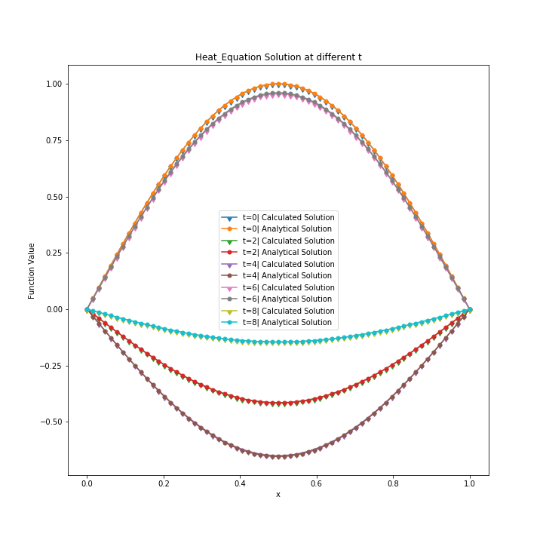

The simulation for the heat equation solution at different t is available at Heat_Equation.mp4

Problem 2:

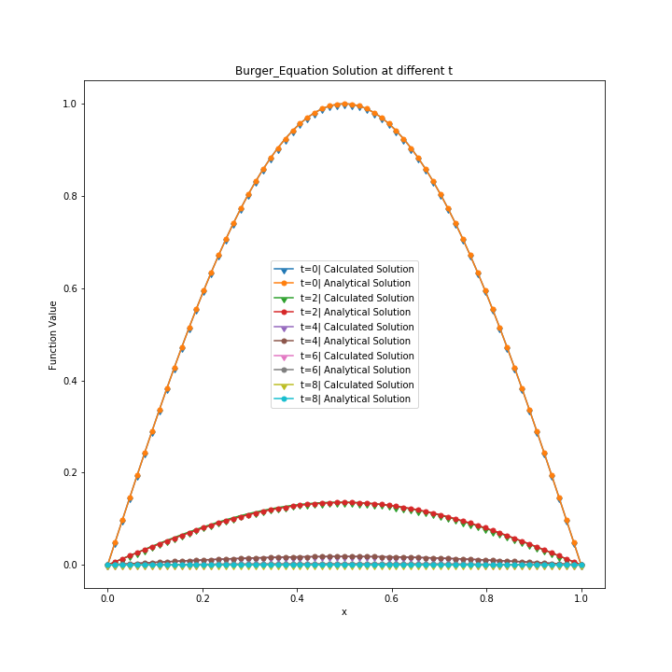

The simulation for Burger’s equation solution at different t is available at Burgers_Equation.mp4

Problem 3.

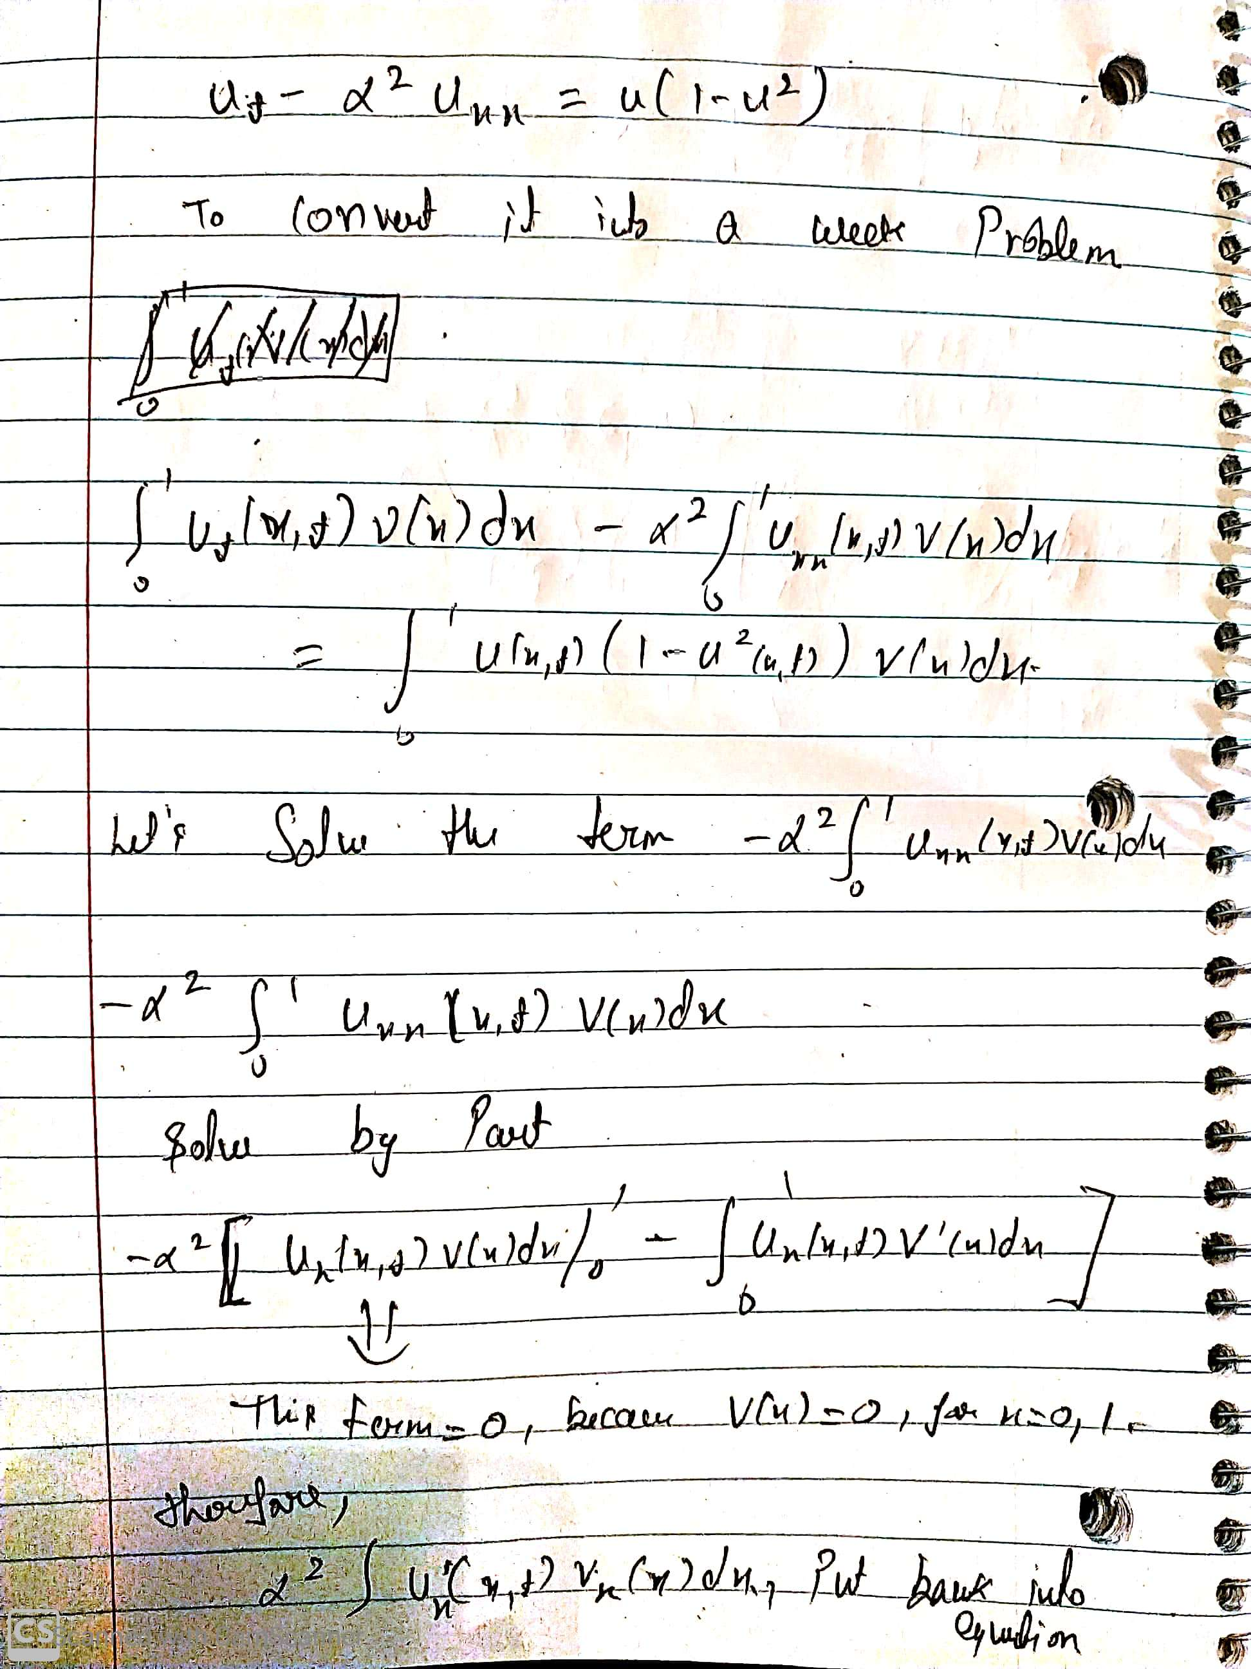

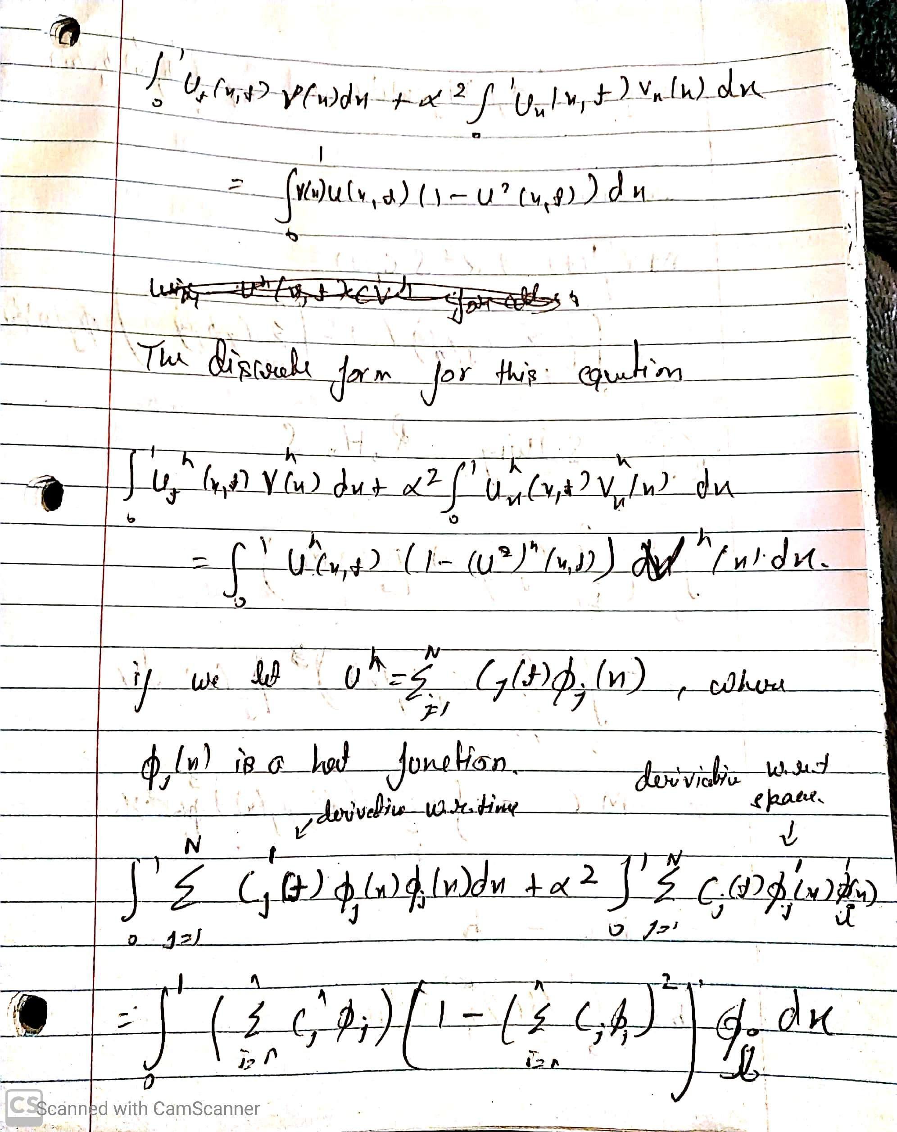

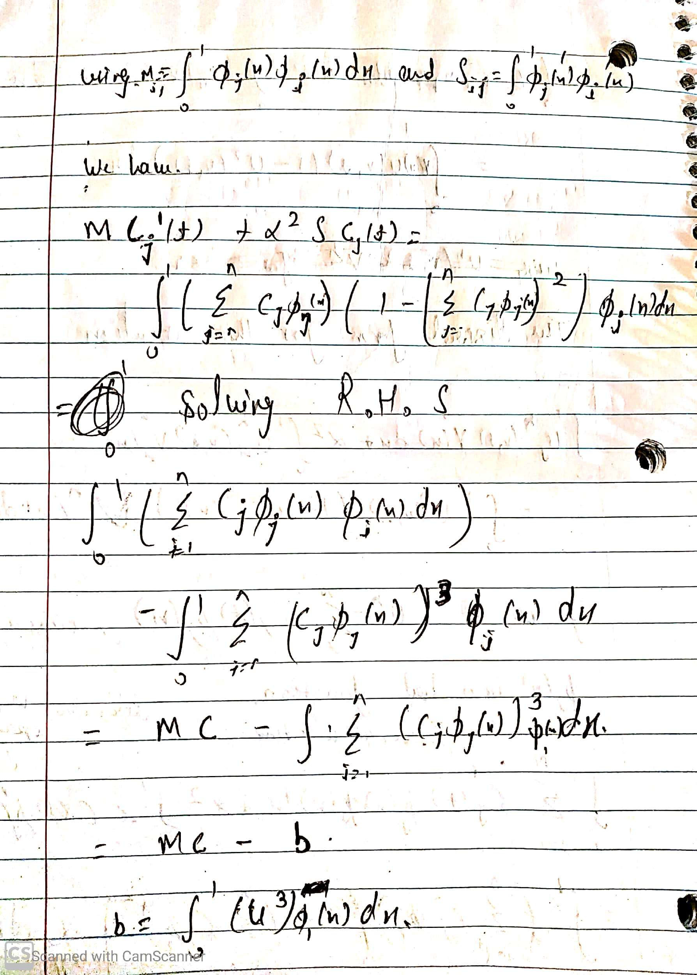

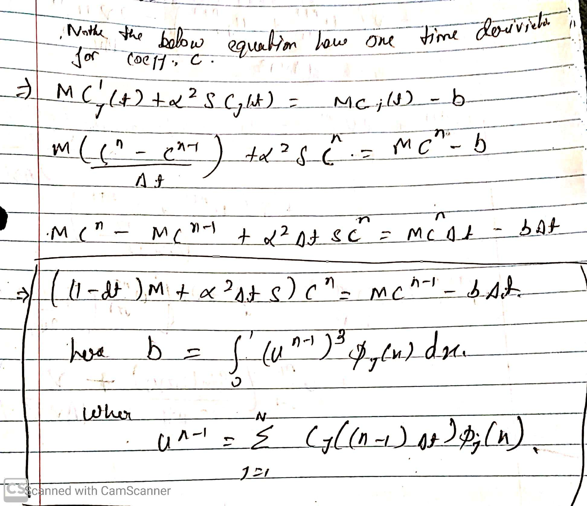

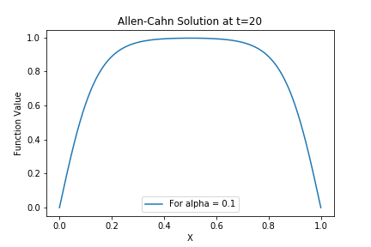

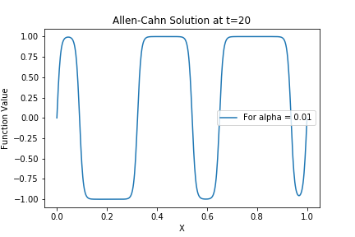

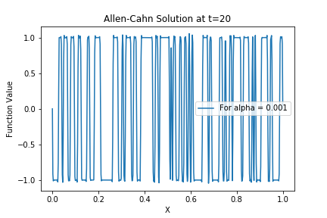

The simulation for Allen-Cahn equation solution at different t is available at Allen_alpha_0.1.mp4, Allen_alpha_0.01.mp4 and Allen_alpha_0.001.mp4 for alpha value 0.1,0.01,0.001 respectively.